 |  |  |  | 
GOVERNMENT OF TAMILNADU
Naan Muthalvan - Project-Based Experiential Learning

OPTIMISING FLIGHT BOOKING DECISIONS THROUGH MACHINE LEARNING PRICE PREDICTIOND
Submitted by
B.YUGADHARANI – (20626ER069)
A.MUTHULAKSHMI-(20626ER051)
M.NAGARANI– (20626ER052)
S.NARMATHA DEVI – (20626ER053)

Under the guidance of
Mrs.K.P.KAVITHA, MCA.,M.Phil.,(Ph.D)

Department of Computer Science


GOVERNMENT ARTS COLLEGE FOR WOMEN , NILAKOTTAI
B(Affiliated To Mother Teresa Women’s University, Kodaikanal)
Reaccredited with ”C” Grade by NAAC
NILAKOTTAI - 624208

APRIL - 2023

GOVERNMENT ARTS COLLEGE FOR WOMEN, NILAKOTTAI

(Affiliated to Mother Teresa Womens University, Kodaikanal)

Reaccredited with ‘C’ Grade by NAAC

Nilakottai - 624208

DEPARTMENT OF COMPUTER SCIENCE

BONAFIDE CERTIFICATE

This is to certify that this is a bonafide record of the project entitled OPTIMIZING FLIGHT BOOKING DECISIONS THROUGH MACHINE LEARNING PRICE PREDICTIONS done By MS.B.YUGADHARANI-(20626ER069), MS.A.MUTHULAKSHMI-(20626ER051),MS.M.NAGARANI-(20626ER052), MS.S.NARMATHA DEVI - (20626ER053) This is submitted in partial fulfillment for the award of the degree of Bachelor of Science in Computer Science in GOVERNMENT ARTS COLLEGE FOR WOMEN, NILAKOTTAI during the period of December 2022 to April 2023.

Project Mentor(s) Head of the Department

Submitted for viva-voce Examination held on _______________

INTERNAL EXAMINER EXTERNAL EXAMINER

1.INTRODUCTION :

“Airline Reservation System” is a java-based desktop application with a purpose ofproviding flight ticket booking and related facilities. This application comprises login facilities for user and admin. Admin has rights to view user contact details and flight operations such as reviewing sea details and adding new flights. Users can look for available flights and reserve flight seats by logging in or registering.
  - Overview:
People who work frequently travel through flight will have better knowledge on best discount and right time to buy the ticket. For the business purpose many airline companies change prices according to the seasons or time duration. They will increase the price when people travel more. Estimating the highest prices of the airlines data for the route is collected with features such as Duraction, Source, Destination, Arrival and Depaeture. Features are taken from chosen dataset and in the price wherein the airline price ticket costs vary overtime.

2.2 Ideation & Brainstorming Map
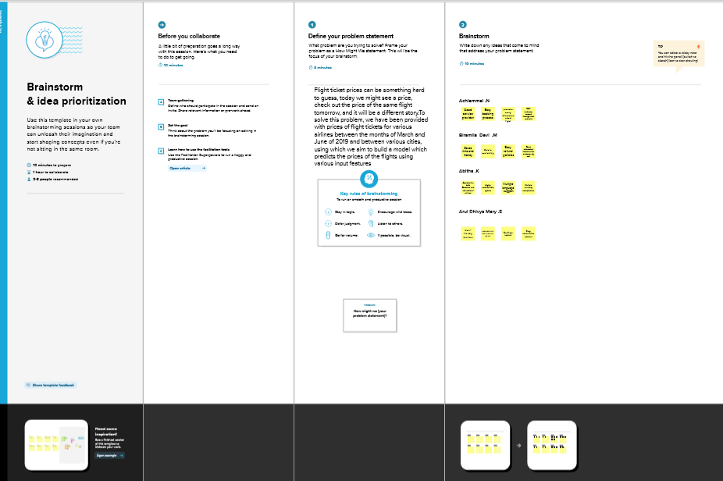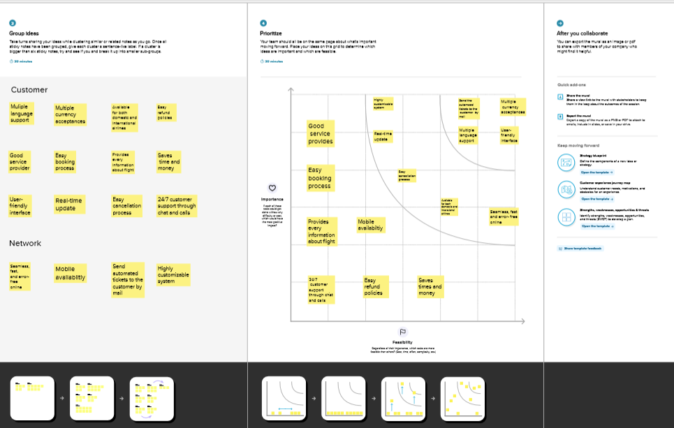

2.RESELT





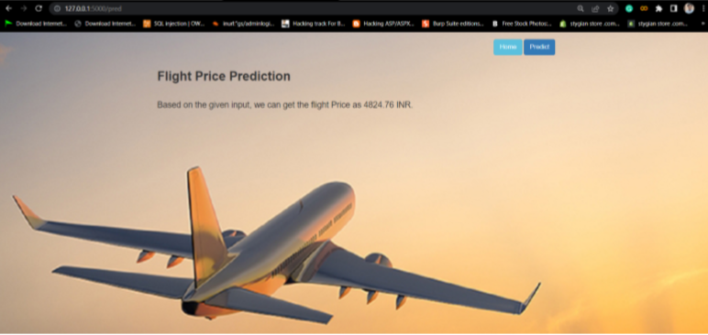
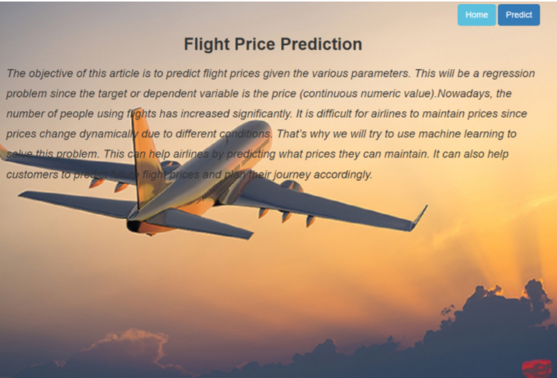

3.ADVANTAGE:

Advantages Of One-Way Airline Tickets

Cost-friendly
Booking a one-way ticket (especially for domestic flights) is considerably more affordable and cheaper with affordable airlines than a round-trip ticket.
Unknown to many, booking a return ticket with a single airline can sometimes be more expensive than taking two different airlines for the trip. One reason for this is that airlines set prices differently for the same destinations. This is especially for individuals making last-minute bookings for a one-way trip.
It is also worth noting that you might pay less for a round-trip ticket with the same airline when you make a last-minute booking, especially when heading to certain parts of Asia and Europe. Keep costs down with single-trip travel insurance.
For multi-destination trips, a one-way flight could cost less than expected compared to if you were to book a return ticket with the same airline.
Using a train, bus, car, or ferry between destinations can lower costs.
With dozens of low-cost airlines to choose from, finding an affordable one for your destination should be relatively easy. Thanks to Google flights, you can compare flight rates with different airlines for both one-way and round trips, making it possible to choose the most affordable one.
Some research might also be required if planning to use points and miles programs to pay for the ticket with different airlines. Luckily, The Points Guy can help you calculate the equivalent of rewards to cash price to determine if the points are enough.

Easy To Spread Costs
The best part of booking a one-way flight is the fact that you can spread the costs. This means you won’t have to pay for multiple flights, especially when planning to travel for several weeks or months.
You’ll thus still have the money meant for the return trip with you, allowing you to spread your costs effectively for your convenience. You can thus book an onward ticket later on when you need to.


Flexible Payment Methods
You can choose to pay for a one-way ticket with your credit card, then the return ticket with your points or miles. With mileage currencies varying from one airline to the other, you can also use the points earned on the first leg of the trip to top up the return trip.
This plan works best if you are just a few points short of mileage currency to pay for a one-way trip. The points accumulated will cater to just that.

Better Itinerary Flexibility
With round-trip flights, one is required to confirm the exact return date with the airline. This could be an issue for anyone without fixed travel plans, whereby they might want to prolong their stay for a few days or wish to travel onward to another country.
One-way flights thus provide improved itinerary flexibility as you don’t have to seek approval to delete or cancel a segment of your travel plans with the airline. Although it is possible to change your onward flight with the airlines, there’s often a fee for the same.

Eliminates The Risk of Automatic Itinerary Cancelation
Most airlines will cancel every other flight on your itinerary should you miss an outbound flight. This is the worst that can happen to anyone, especially if it is a round-trip ticket.
Booking a one-way flight, however, gives you some insurance that one trip won’t be affected should you miss a flight on one itinerary. This makes it less hectic and easier to manage.


Disadvantages Of One-Way Airline Tickets

Easy To Be Turned Away at Border Control
Some countries require one to have/provide proof of onward travel before they can be allowed in the country. One of the reasons for this is to mitigate/curb unlawful immigration or overstaying their visa.
According to research, it is the airline’s responsibility to check each passenger for onward travel (for one-way tickets) and will foot the cost of flying the person back to their home country if they have none. This makes one-way international tickets quite tricky unless one can provide proof of onward travel at the check-in desk.

It Might Cost More
One-way tickets outside of the US, to Europe and Asia, among several other international destinations, can be expensive. This is particularly the case for destinations popular with business travelers.
Some airlines may also penalize your mileage points through additional origination surcharges if you choose a one-way flight. You may also have issues with delays and end up having to pay for last-minute hotels too.

Multiple Change and Cancelation Fees
While flexible, you could be slapped with change and cancellation fees should you change one-way flights several times. This is unlike a round-trip ticket that only allows for a one-change or cancellation fee.
Flyer Award Restrictions
Some airlines have restrictions on way-way awards.

Getting Refunds Can Be a Hustle
Some one-way tickets are nonrefundable, especially if you booked with a different airline for the return trip. Should the airline cancel a segment of your itinerary, the chances of getting a refund for the trip can be tricky.
This is unlike round trips with the same airline, where they are required to refund or rebook a ticket for you for the trip.

Travel Insurance Restrictions
Travel insurance can be an issue if one chooses to use a one-way flight. Most insurance companies require one to have a return ticket for them to cover you fully during the trip. There are, however, several companies that do not impose such restrictions on ex-pats and digital nomads.

4.CONCLUSION:
We learn that ML models can be used to predict prices based on earlier data more correctly. The presented paper reflects the dynamic change in the cost of flight tickets from which we get the information about the increase or decrease in the price as per the days, weekends, and the time of the day. With the Ml algorithm applied on various datasets, better results can be obtained for prediction. The error values that we got for Artificial Neural Network are comparatively high but for obtaining lesser values we can use evolutionary algorithms of ANN like genetic algorithms in the future.
5.FUTURE SCOPE:

The Online Airline Reservation System market research report is proficient and top to bottom research by specialists on the current state of the industry. This statistical surveying report gives the most up to date industry information and industry future patterns, enabling you to distinguish the items and end clients driving income development and benefit. It centres around the real drivers and restrictions for the key players and present challenge status with development prospects. Additionally, the report displays potential opportunities in the Online Airline Reservation System market and also it features the effect of the different elements bringing about preventing or boosting the market analysis.

6.APPENDIX
A source code
import numpy as np
import pandas as pd
import matplotlib.pyplot as plt
import seaborn as sns
from sklearn.model_selection import train_test_split
from sklearn.ensemble import RandomForestClassifier,GradientBoostingClassifier
from sklearn.tree import DecisionTreeClassifier
from sklearn.neighbors import KNeighborsClassifier
from sklearn.metrics import f1_score
from sklearn.metrics import classification_report,confusion_matrix
import warnings
import pickle
from scipy import stats
warnings.filterwarnings('ignore')
plt.style.use('fivethirtyeight')

data=pd.read_csv("/content/Data_Train_1.csv")
data.head()
for i in Category:
print(i,data[i].uniquedata.Date_of_journey=data.Date_of_Journey.str.split('/')
data.Date_of_Journey
data['Date']=data.Date_of_Journey.str[0]
data['Month']=data.Date_of_Journey.str[1]
data['Year']=data.Date_of_Journey.str[2]
data.Total_Stops.unique()
data.Route=data.Route.str.split('')
data.Route
data['City1']=data.Route.str[0]
data['City2']=data.Route.str[1]
data['City3']=data.Route.str[2]
data['City4']=data.Route.str[3]
data['City5']=data.Route.str[4]
data['City6']=data.Route.str[5]

data.Dep_Time=data.Dep_Time.str.split(':')
data['Dep_Time_Hour']=data.Dep_Time.str[0]
data['Dep_Time_Mins']=data.Dep_Time.str[1]
data.Arrival_Time=data.Arrival_Time.str.split('')
data['Arrival_date']=data.Arrival_Time.str[1]
data['Time_of_Arrival']=data.Arrival_Time.str[0]
data['Time_of_Arrival']=data.Time_of_Arrival.str.split(':')
data['Arrival_Time_Hour']=data.Time_of_Arrival.str[0]
data['Arrival_Time_Mins']=data.Time_of_Arrival.str[1]
data.Duration=data.Duration.str.split('')
data['Travel_Hours']=data.Duration.str[0]
data['Travel_Hours']=data['Travel_Hours'].str.split('h')
data['Travel_Hours']=data['Travel_Hours'].str[0]
data.Travel_Hours=data.Travel_Hours
data['Travel_Mins']=data.Duration.str[1]
data.Travel_Mins=data.Travel_Mins.str.split('m')
data.Travel_Mins=data.Travel_Mins.str[0]
data.Total_Stops.replace('non_stop',0,inplace=True)
data.Total_stops=data.Total_Stops.str.split('')
data.Total_Stops=data.Total_Stops.str[0]
data.Additional_Info.unique()
data.Additional_Info.replace('No Info','No info',inplace=True)
data.isnull().sum()
data.drop(['City4','City5','City6'],axis=1,inplace=True)
data.drop(['Date_of_Journey','Route','Dep_Time','Arrival_Time','Duration'],axis=1,inplace=True)
data.drop(['Time_of_Arrival'],axis=1,inplace=True)
data.isnull().sum()
data['City3'].fillna('None',inplace=True)
data['Arrival_date'].fillna(data['Date'],inplace=True)
data['Travel_Mins'].fillna(0,inplace=True)
data.info()
data.Date=data.Date.astype('int64')
data.Month=data.Month.astype('int64')
data.Year=data.Year.astype('astype')
data.Dep_Time_Hour=data.Dep_Time_Hour.astype('astype')
data.Dep_Time_Hour=data.Dep_Time_Hour.astype('int64')
data.Dep_Time_Mins=data.Dep_Time_Mins.astype('int64')
data.Arrival_date=data.Arrival_date.astype("int64")
data.Arrival_Time_Hour=data.Arrival_Time_Hour.astype('int64')
data.Arrival_Time_Mins=data.Arrival_Time_Mins.astype('int64')
data.Travel_Mins=data.Travel_Mins.astype('int64')
data[data['Travel_Hours']=='5m']
data.drop(index=6474,inplace=True,axis=0)
data.Travel_Hours=data.Travel_Hours.astype('int64')
categorical=['Airline','Source','Destination','Additional_Info','City1']
numerical=['Total_Stops','Date','Month','Year','Dep_Time_Hour','Dep_Time_Mins','Arrival_Time_Hour','Arrival_Time_Mins','Travel_Hours','Travel_Mins']
from sklearn.preprocessing import LabelEncoder
le=LabelEncoder()
data.Airline=le.fit_transform(data.Airline)
data.Source=le.fit_transform(data.Source)
data.Destination=le.fit_transform(data.Destination)
data.Total_Stops=le.fit_transform(data.Total_Stops)
data.City1 =le.fit_transform(data.City1 )
data.City2=le.fit_transform(data.City2)
data.City3=le.fit_transform(data.City3)
data.Additional_Info=le.fit_transform(data.Additional_Info)
data.head()
data.head()
data=data[['Airline','Source','Destination','Date','Month','Year','Dep_Time_Mins','Arrival_date','Arrival_Time']]
data.head()
data.describe()
import seaborn as sns
c=1
plt.figure(figsize=(20,45))
for i in Categorical:
plt.subplot(6,3,c)
sns.countplot(data[i])
plt.xtricks(rotation=90)
plt.tight_layout(pad=3.0)
plt.show()
plt.figure(figsize=(15,8))
sns.distplot(data.Price)
sns.heatmap(data.corr(),annot=True)
import seaborn as sns
sns.boxplot(data['Price'])

y=data['Price']
x=data.drop(columns=['Price'],axis=1)
from sklearn.preprocessing import StandardScaler
ss=StandardScaler()
x_Scaled=ss.fit_transform(x)
x_scaled=pd.DataFrame(x_scaled,columns=x.columns)
x_scaled.head()
from sklearn.model_selection import train_test_split
x_train,x_test,y_train,y_test=train_test_split(x,y,test_size=0.2,random_state=42)
x_train.head()
from sklearn.ensemble import RandomForestRegressor,GradientBoostingRegressor,AdaBoostRegressor
rfr=RandomForestRegressor()
gb=GradientBoostingRegressor()
ad=AdaBoostRegressor()

from sklearn.metrics import r2_score,mean_absolute_error,mean_squared_error
for i in [rfr,gb,ad]:
i.fit(x_train,y_train)
y_pred=i.predict(x_test)
test_score=r2_score(y_test,y_pred)
train_score=r2_score(y_train,i.predict(x_train))
if abs(train_score-test_score)<=0.2:
print(i)
print("R2 score is",r2_score(y_test,y_pred))
print("R2 for train data",r2_score(y_train,i.predit(x_train)))
print("Mean Absolute Error is",mean_absolute_error(y_pred,y_test))
print("Mean Squared Error is",mean_squared_error(y_pred,y_test))
print("Root Mean Squared Error is",(mean_squared_error(y_pred,y_test,squared=False)))
from sklearn.neighbors import KNeighborsRegressor
from sklearn.svm import SVR
from sklearn.tree import DecisionTreeRegressor
from sklearn.metrics import r2_score,mean_absolute_error,mean_squared_error
Knn=KNeighborsRegressor()
svr=SVR()
dt=DecisionTreeRegressor()
for i in [Knn,svr,dt]:
i.fit(x_train,y_train)
y_pred=i.predict(x_test)
test_score=r2_score(y_test,y_pred)
train_score=r2_score(y_train,i.predict(x_train))
if abs(train_score-test_score)<=0.1:
print(i)
print("R2 score is",r2_score(y_test,y_pred))
print("R2 for train data",r2_score(y_train,i.predit(x_train)))
print("Mean Absolute Error is",mean_absolute_error(y_test,y_pred))
print("Mean Squared Error is",mean_squared_error(y_test,y_pred))
print("Root Mean Squared Error is",(mean_squared_error(y_test,y_pred,squared=False)))

from sklearn.model_selection import cross_val_score
for i in range(2,5):
cv=cross_val_score(rfr,x,y,CV=i)
print(rfr,cv.mean())
from sklearn.model_selection import RandomizedSearchCV

param_grid={'n_estimators':[10,30,5070,100],'max_depth':[None,1,2,3],'max_features':['auto','sqrt']}
rfr=RandomForestRegressor()
rf_res=RandomizedSearchCV(estimator=rfr,param_distributions=param_grid,cv=3,verbose=2,n_jobs=-1)
rf_res.fit(x_train)
gb=GradientBoostingRegressor()
gb_res=RandomizedSearchCV(estimator=gb,param_distributions=param_grid,cv=33,verbose=2,n_jobs=-1,)
gb_res.fit(x_train,y_train)

rfr=RandomForestRegressor(n_estimators=10,max_features='sqrt',max_depth=None)
rfr.fit(x_train,y_train)
y_train_pred=rfr.predict(x_train)
y_test_pred=rfr.predict(x_test)
print("train accuracy",r2_score(y_train_pred,y_train))
print("test accuracy",r2_score(y_test_pred,y_test))
Knn=KNeigborsRegressor(n_neighbors=2,algorithm='auto',metric_params=None,n_jobs=-1)
Knn.fit(x_train,y_train)
y_train_pred=Knn.predict(x_train)
y_test_pred=Knn.predict(x_test)
print("train accuracy",r2_score(y_train_pred,y_train))
print("test accuracy",r2_score(y_test_pred,y_test))
rfr=RandomForestRegressor(n_estimators=10,max_features='sqrt',max_depth=None)
rfr.fit(x_train,y_train)
y_train_pred=rfr.predict(x_train)
y_test_pred=rfr.predict(x_test)
print("train accuracy",r2_score(y_train_pred,y_train))
print("test accuracy",r2_score(y_test_pred,y_test))

Price_list=pd.DataFrame({'Price':PriceS})
Price_list
import pickle
pickle.dump(rfr,open('model1.pk1','wb'))
import pickle
pickle.dump(rfr,open('model1.pk1','wb'))
from flask import Flask,render_template,request
import numpy as np
import pickle
model=Pickle.load(open(r"model1.pkl",'rb'))
def home1():
return render_template('predict.html')
def predict():
x=[[int(x) for x in request.form.values()]]
print(x)
x=np.array(x)
print(x.shape)

print(x)
pred=model1.predict(x)
print(pred)
return render_template('submit.html',prediction_test=pred)

